Part Number: PTR07-53100

Kit Contents
Item # | Quantity Reqd. | Description
1 | 2 | Front Springs
2 | 2 | Rear Springs
3 | 1 | Hardware Bag
Hardware Bag Contents
Item # | Quantity Reqd. | Description
1 | 2 | Front Shock Absorber Locking Nuts
2 | 1 | Installation Instructions
3
Additional Items Required For Installation
Item # | Quantity Reqd. | Description
1
Conflicts
None
General Applicability
IS 250 & IS 350 Convertible only
Recommended Sequence of Application
Item # | Accessory
1 | F-Sport Springs
2 | F-Sport Exhaust
3 | F-Sport Rear Brakes
*Mandatory
Recommended Tools
Personal & Vehicle Protection | Notes
Fender Covers
Safety Glasses
Special Tools | Notes
Spring Compressor
Installation Tools | Notes
Torque Wrench | 3/8” & ½” drive
Ratchet | 3/8” & ½” drive
Wrenches | 19mm
Sockets | 10, 14, 17, 19mm
Snap-On | QXXM19A or QXOM19A
Hexagon Wrench | 6 mm
Nylon Pry Tool
Special Chemicals | Notes
Vehicle Service Parts (may be required for reassembly)
Item # | Quantity Reqd. | Description
1 | 2 | 90467-12069 white trunk trim clip
1 | 3 | 90467-10167 blue trunk trim clip
1 | 7 | 90467-08186-C0 black trunk trim clip
Legend
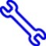
STOP: Damage to the vehicle may occur. Do not proceed until process has been complied with.
OPERATOR SAFETY: Use caution to avoid risk of injury.
CAUTION: A process that must be carefully observed in order to reduce the risk of damage to the accessory/vehicle and to ensure a quality installation.
TOOLS & EQUIPMENT: Used in Figures calls out the specific tools and equipment recommended for this process.
REVISION MARK: This mark highlights a change in installation with respect to previous issue.
SAFETY TORQUE: This mark indicates that torque is related to safety.

Care must be taken when installing this accessory to ensure damage does not occur to the vehicle. The installation of this accessory should follow approved guidelines to ensure a quality installation.

These guidelines can be found in the "Accessory Installation Practices" document.

This document covers such items as:-
- Vehicle Protection (use of covers and blankets, cleaning chemicals, etc.).
- Safety (eye protection, rechecking torque procedure, etc.).
- Vehicle Disassembly/Reassembly (panel removal, part storage, etc.).
- Electrical Component Disassembly/Reassembly (battery disconnection, connector removal, etc.).

Please see your Lexus dealer for a copy of this document.

Remove the Rear Shock Absorber/Spring Assemblies.
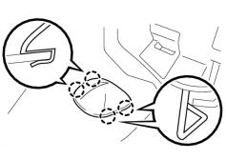
  - Remove the spring and shock absorber assembly access covers. The passenger’s side is shown (Fig. 1-1).
Nylon pry tool
Fig. 1-1
NOTE: The roof must be in the closed position.

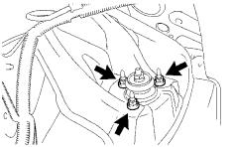
  - Remove the 3 nuts on the upper side of the rear shock absorber assembly (Fig. 1-2).
14mm socket & ratchet
Fig. 1-2
  - Raise the vehicle and remove the rear wheels.
CAUTION: Do not use an impact wrench on wheel locks (if equipped).

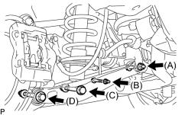
  - Loosen (do not remove) the lower rear No. 2 suspension arm nut (A, Fig. 1-3).
19mm socket & wrench and ratchet
Fig. 1-3
CAUTION: Do not remove the nut.
  - Remove bolt B and the nut (Fig. 1-3).
  - Disconnect the stabilizer link assembly and height control sensor link bracket from the rear No. 2 suspension arm assembly (Fig. 1-3).
  - Remove bolt C and the nut (Fig. 1-3).
CAUTION: The nut has a locking feature. Remove the bolt and nut by turning the BOLT while the nut is held in place.
  - Remove bolt D and the nut on the axle carrier side and lower the rear No. 2 suspension arm assembly from the knuckle assembly (Fig. 1-3).
CAUTION: The nut has a locking feature. Remove the bolt and nut by turning the BOLT while the nut is held in place.
  - Remove two fender liner nuts to access the rear shock absorber assembly.
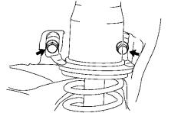
  - Remove the 2 bolts and the rear shock absorber assembly from the body (Fig. 1-4). Retain the bolts for reassembly.
19mm socket & ratchet
Fig. 1-4
  - Remove the spring from shock absorber assembly.
    - Use a spring compressor to compress the rear coil spring until the tension is removed from the shock absorber assembly.

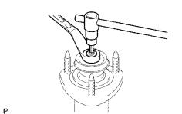
    - Remove the upper shock absorber nut. If the shaft spins with the nut, hold the rod of the rear shock absorber assembly with a 6mm hexagon wrench (Fig. 1-5).
17mm socket, ratchet & 6mm hex wrench

Fig. 1-5
    - Note the order and position of the washer, bushings and jounce bumper for reassembly.
  - Discard the OE coil spring.
  - Repeat Step 1 on the other side of the vehicle.

Install the F-Sport Rear Spring.
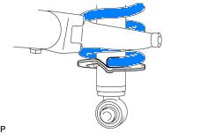
  - Fit the rear coil spring end into the recessed part of the rear lower shock absorber seat (Fig. 2-1).
Fig. 2-1

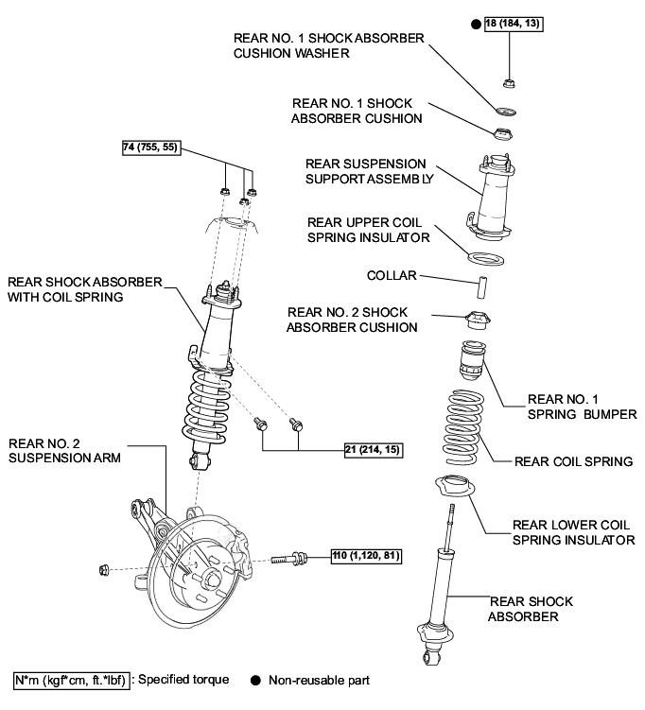
  - Reassemble the shock absorber/spring assembly as shown below (Fig. 2-2).
Fig. 2-2

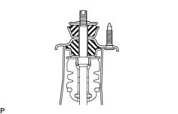
  - Ensure the cushions and washer (lip turned up) are assembled in the correct direction and order (Fig. 2-3).
Fig. 2-3

  - Torque the new shock absorber shaft lock nut (Fig. 2-4).
17mm socket, torque wrench & 6mm hex wrench

Fig. 2-4

Torque: 18 N·m (184 kgf·cm, 13 ft·lbf)
  - Repeat Step 2 for the other side.

Install the Rear Shock Absorber /Spring Assemblies.
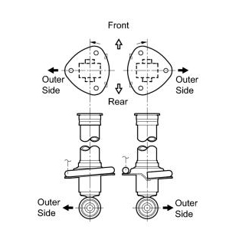
  - Ensure that the left (driver’s side) coil spring end faces towards the front of the vehicle and the right coil spring end faces towards the rear (Fig. 3-1).
Fig. 3-1

  - Temporarily install the rear shock absorber assembly with the 2 bolts removed in Step 1(j) (Fig. 3-2).
19mm socket & ratchet
Fig. 3-2
NOTE: Leave the bolts loose.

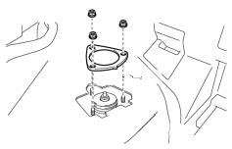
  - Install the 3 nuts on the upper side of the rear shock absorber assembly (Fig. 3-3).
19mm socket & torque wrench
Fig. 3-3

Torque: 74 N·m (755 kgf·cm, 55 ft·lbf)
  - Install the spring and shock absorber assembly trim covers.

  - Torque the 2 bolts on the rear shock absorber assembly (Fig. 3-4).
19mm socket & torque wrench
Fig. 3-4

Torque: 21 N·m (214 kgf·cm, 15 ft·lbf)
  - Install the rear fender liner nuts.

  - Raise the lower suspension arm and temporarily install the nuts and bolts for the stabilizer link assembly (B), shock absorber (C) and knuckle (D) (Fig. 3-5).
19mm socket & wrench and ratchet
Fig. 3-5

CAUTION: Confirm that the height control sensor link is positioned correctly and not folded inward.
  - Repeat Step 3 for the other side of the vehicle.
  - If the F-Sport rear sway bar will be installed, do so now following the F-Sport Sway Bar Set PPO instructions.
  - Install the rear wheel/tire assemblies onto the vehicle. Hand start the lug nuts.
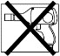
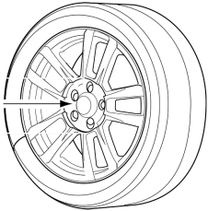
  - Use a torque wrench to tighten the lug nuts in sequence 1 through 5 to 103N∙m (76 ft-lbf) (Fig. 3-6).
2x

Fig. 3-6
Torque 2 Cycles
(All Lugs/Locks)
Torque: 103 N·m (1,050 kgf·cm, 76 ft·lbf)
  - Re-torque all of the lug nuts in same the 1-5 sequence (Fig. 3-6).
Torque: 103 N·m (1,050 kgf·cm, 76 ft·lbf)
CAUTION: DO NOT USE AN IMPACT WRENCH TO INSTALL OR REMOVE WHEEL LOCKS.

Remove the Front Shock Absorber/Spring Assemblies.
  - Remove the front wheels.
CAUTION: Do not use an impact wrench on wheel locks (if equipped).
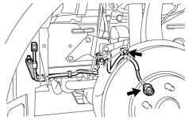
  - Detach the speed sensor wire from the shock absorber assembly and disconnect it from the speed sensor (Fig. 4-1).
10mm socket & ratchet
Fig. 4-1

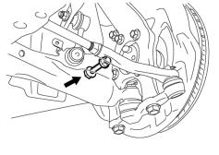
  - Remove the nut and bolt holding the lower end of the shock absorber (Fig. 4-2).
19mm socket & wrench and ratchet
Fig. 4-2
  - Remove the engine room side covers.

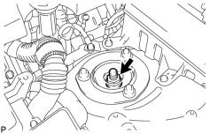
  - Loosen the front shock absorber lock nut (Fig. 4-3).
17mm socket & ratchet
Fig. 4-3
NOTE: Do not remove the lock nut.

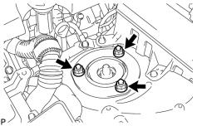
  - Remove the 3 nuts on the upper side of the front suspension support (Fig. 4-4).
14mm socket & ratchet
Fig. 4-4
NOTE: The lower arm bushing preload will not allow the shock absorber assembly to fall.

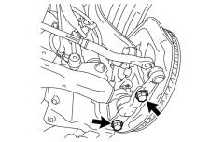
  - Remove the 2 bolts from the front lower ball joint (Fig. 4-5).
19mm socket & ratchet
Fig. 4-5
  - Remove the shock absorber/spring assembly from the vehicle.
  - Repeat Step 4 on the other side of the vehicle.

Install the F-Sport Front Spring.
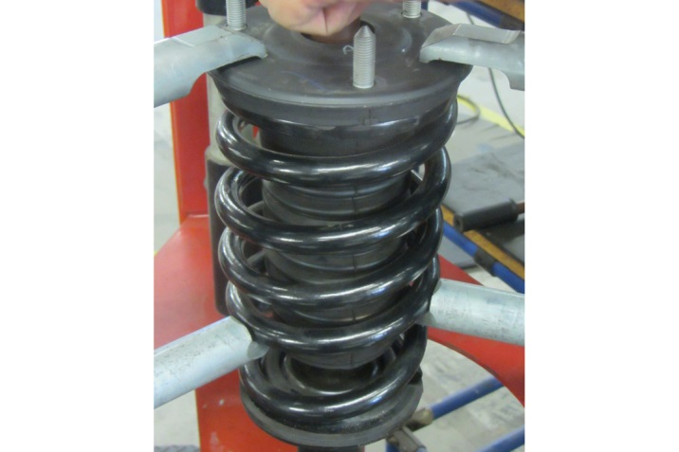
  - Compress the spring enough to remove tension from the upper spring support (Fig. 5-1).
Spring compressor
Fig. 5-1

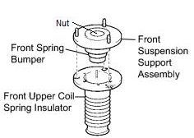
  - Remove the lock nut (Fig. 5-2). It will not be reused.
17mm socket & ratchet
Fig. 5-2
  - Remove the front suspension support assembly with the front upper coil spring insulator (Fig. 5-2). Retain them for reinstallation.
  - Remove the coil spring.

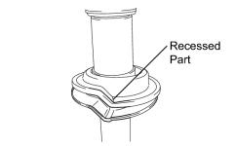
  - Confirm that the lower spring insulator is indexed properly and free of debris (Fig. 5-3).
Fig. 5-3
  - Compress a new front spring and place it over the shock absorber assembly.

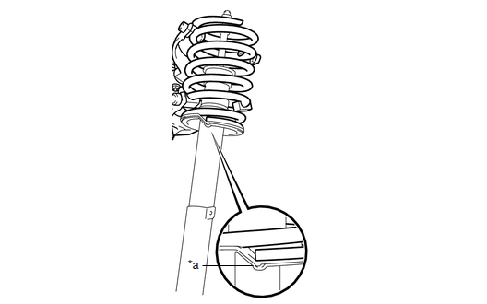
  - Confirm that the end of the spring sits in the stepped portion (*a) of the lower spring seat (Fig. 5-4).
Fig. 5-4
NOTE: Ensure the F-Sport logo is facing outward.

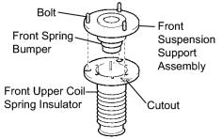
  - Install the front spring bumper onto the front suspension support assembly (Fig. 5-5).
Fig. 5-5
  - Align the bolt heads of the front suspension support assembly with the cutouts of the front upper coil spring insulator (Fig. 5-5).
  - Install the front upper coil spring insulator on the front suspension support assembly (Fig. 5-5).
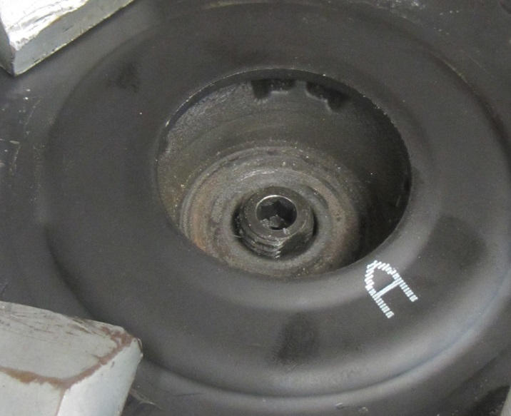
  - Match the shape of the piston shaft end to the hole in the front suspension support assembly to install the front shock absorber (Fig. 5-6).
Fig. 5-6
Flats

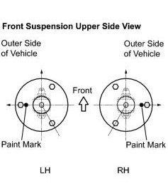
  - Turn the front suspension support assembly so that the bolts align to the lower shock absorber eyelets (Fig. 5-7).
17mm socket & ratchet
Fig. 5-7
  - Temporarily tighten a supplied lock nut to the front shock absorber.

Install the Front Shock Absorber/Spring Assembly.
  - Install the front shock absorber assembly into the vehicle and tighten the 3 nuts on the suspension support (engine bay) side (Fig. 6-1).
14mm socket & torque wrench
Fig. 6-1
Torque: 67 N·m (683 kgf·cm, 49 ft·lbf)

  - Install the front shock absorber lower side on the front lower suspension arm and insert the bolt from the rear of the vehicle (Fig. 6-2).
19mm socket & wrench and ratchet
Fig. 6-2
  - Temporarily tighten the nut while holding the bolt.
NOTE: The nut will be fully tightened after settling the suspension.

  - Replace the 2 bolts into the front lower ball joint (Fig. 6-3).
17mm socket & torque wrench
Fig. 6-3
Torque: 120 N·m (1,220 kgf·cm, 89 ft·lbf)

  - Install the front speed sensor to the front shock absorber and reconnect it (Fig. 6-4).
10mm socket & torque wrench
Fig. 6-4

Torque: 6.0 N·m (61 kgf·cm, 53 in·lbf)
  - Repeat Step 6 on the other side of the vehicle.
  - If the F-Sport front sway bar will be installed, do so now following the F-Sport Sway Bar Set instructions, otherwise skip to Step 6(h).
  - Install the front wheel/tire assemblies onto the vehicle. Hand start the lug nuts.
  - Use a torque wrench to tighten the lug nuts in sequence 1 through 5 to 103N∙m (76 ft-lbf) (Fig. 6-5).
2x

Fig. 6-5
Torque 2 Cycles
(All Lugs/Locks)
Torque: 103N∙m (76 ft-lbf)
  - Re-torque all of the lug nuts in same the 1-5 sequence (Fig. 6-5).
Torque: 103N∙m (76 ft-lbf)
CAUTION: DO NOT USE AN IMPACT WRENCH TO INSTALL OR REMOVE WHEEL LOCKS.

Tighten the Suspension Component Fasteners.
  - Lower the vehicle onto alignment car stands with slip plates under all four wheels. Set the parking brake and lower the lift arms away from the vehicle.
  - Jounce the vehicle front and rear to settle the suspension.
  - Torque the front lower shock absorber bolt (Fig. 7-1).
19mm socket & wrench and torque wrench
Fig. 7-1
Torque: 157 N·m (1,600 kgf·cm, 116 ft·lbf)

  - Torque the new front shock absorber assembly lock nut (Fig. 7-2).
17mm socket & torque wrench
Fig. 7-2
Torque: 28 N·m (286 kgf·cm, 21 ft·lbf)
  - Install the engine room side covers.

  - Torque the nuts and bolts on the rear No. 2 suspension arm assembly (Fig. 7-3).
19mm socket & wrench and torque wrench
Fig. 7-3

Torque(A): 140 N·m (1,426 kgf·cm, 103 ft·lbf)

Torque(B): 27 N•m (275 kgf•cm, 20 ft·lbf)

Torque(C): 110 N·m (1,120 kgf·cm, 80 ft·lbf)

Torque(D): 161 N•m (1,640 kgf•cm, 118 ft·lbf)
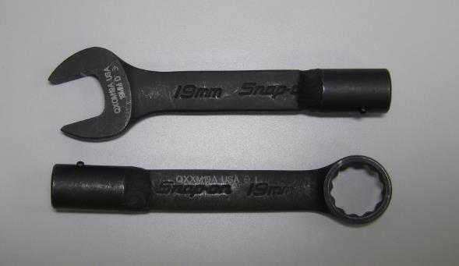
NOTE: Nut A on the RH side cannot be accessed with a 19mm socket. Snap-on Torque Head, P/N QXXM19A or QXOM19A (Fig. 7-4) is recommended to be used and torqued to the spec above.
Fig. 7-4
  - Repeat Step 7 on the other side of the vehicle.

Adjust the Wheel Alignment.
  - Adjust the front toe settings.

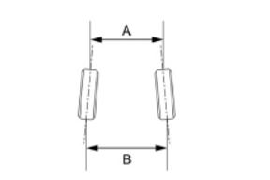
Front Toe-In (Total) (Fig. 8-1)
Fig. 8-1
B - A: 1.0 +/- 2.0 mm (0.04 +/- 0.08 in.)
    - Confirm the steering wheel is locked in the straight ahead position.
    - Remove the outer steering rack boot clips from the boots.

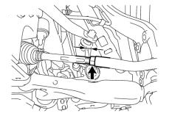
    - Loosen the front tie rod end locking nuts (Fig. 8-2).
Fig. 8-2
17mm & 19mm wrench
    - Turn the right and left steering rack ends by an equal amount to adjust the toe-in.
    - Make sure that the thread length of the right and left steering rack ends are the same (small arrows, Fig. 8-2).
    - Tighten the front tie rod end locking nut (Fig. 8-2).

Torque: 56 N·m (571 kgf·cm, 41 ft·lbf)
NOTE: Temporarily tighten the lock nut while holding the hexagonal part of the steering rack end so that the lock nut and the steering rack end do not turn together. Hold the flat of the tie rod end and tighten lock nut.
    - Replace the steering rack boots on the seats and install the steering rack boot clips.
NOTE:
- Make sure the steering rack boots are not twisted.
- Make sure the steering rack boot clips are facing towards the front of the vehicle.

  - Adjust the rear toe settings.

Rear Toe-In (Total) (Fig. 8-3)
Fig. 8-3
B - A: 3.0 +/- 2.0 mm (0.12 +/- 0.08 in.)

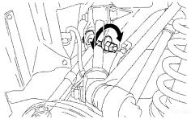
    - Loosen the toe cam lock nut (19mm socket, Fig. 8-4).
Fig. 8-4
19mm socket, 22mm socket, ratchet & torque wrench
    - Turn the adjust cams by an equal amount to adjust toe-in.
  - Tighten the toe cam lock nut (Fig. 8-4).

Torque: 50 N-m (510 kgf·cm, 37 ft·lbf)

Accessory Function Checks
Check for noise

Vehicle Function Checks
Confirm VSC light is not on
Confirm ASF OFF light is not on
Confirm all hardware with torque values are tight

Confirm all springs are seated properly

Speed sensor wires are plugged in
Height sensor links are positioned correctly
Loose hardware

Vehicle Appearance Check
After accessory installation and removal of protective cover(s), perform a visual inspection.

Ensure no damage (including scuffs and scratches) was caused during the installation process.
(For PPO installations, refer to TMS Accessory Quality Shipping Standard.)

